Andrew Stiles
CSD-430
Assignment 7-1: Project Part 2
10/12/2025

addMovieForm.jsp
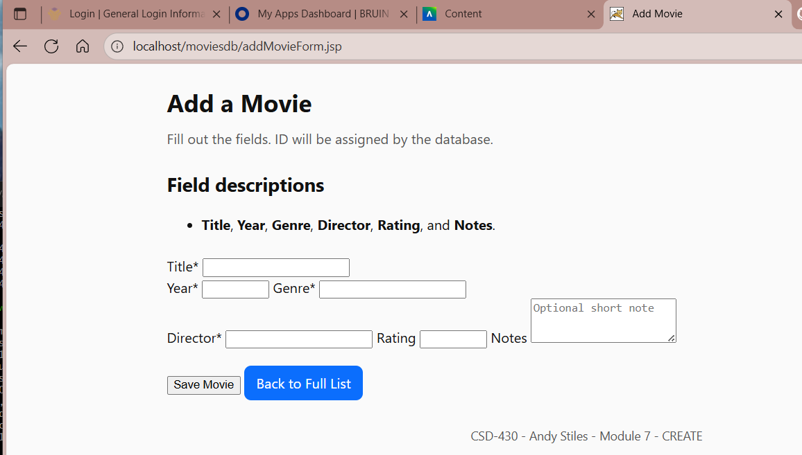

addMovie.jsp
